Assignment 4

Dijkstra's (Uniform Cost) Search

| Node 1 | Node 2 | Cost |
| --- | --- | --- |
| U.S. East Coast | Canada | 1.5 |
| U.S. East Coast | Spain | 2.7 |
| U.S. East Coast | Brazil | 3.3 |
| Canada | Turkey | 3.1 |
| Spain | Nigeria | 2.6 |
| Turkey | Nigeria | 0.5 |
| Brazil | Nigeria | 1.9 |

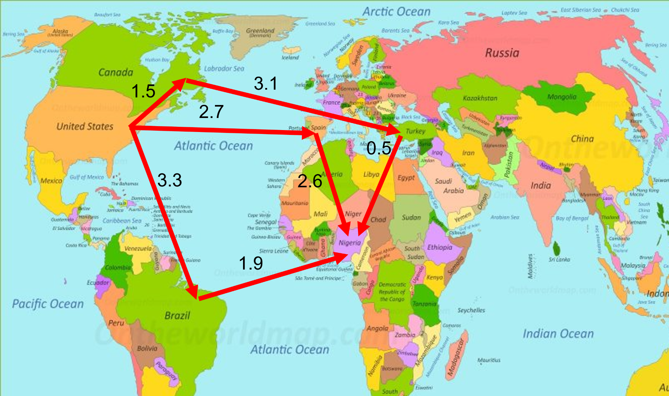

1. Apply Dijkstra's (Uniform Cost) Search to find the shortest path from the U.S. East Coast to Nigeria. Show the steps on how the different flight legs are expanded.
   1. U.S. East Coast
   2. Canada (1.5)
   3. Spain (2.7)
   4. Brazil (3.3)
   5. Turkey (4.6)
   6. Nigeria (5.1)